The purpose of 3D Immersion is to develop a powerful three-dimensional polygon graphics engine that is so versatile that it can be used to simulate the real, physical world. The program has no single purpose other than to provide an expandable base that can be used to learn, teach, or simulate physics, chemistry, and real world situations. The only limiting factor being, one’s imagination!
Purpose
Materials
- Borland 5.01 C/C++ Compiler
- Microsoft Windows ’95
- DELL Inspiron 3000 233MHz Notebook
- North-CAD 3D Modeller
- Paint Shop Pro 4.1
- Flights of Fantasy
Procedure
- I did a considerable amount of reading in a short time to learn what is involved in simulating the third dimension on a computer.
- Next, I began writing the documentation on my intentions and goals for the project. For example, I decided to record a revisions log throughout the development process, decided that I would need some form of a scripting language so that each object could have it’s own characteristics and respond to message’s so the programs scope would be boundless. I decided upon the use of Dynamic Link Libraries that can be associated with objects and respond to messages.
- My first concern was to develop my very own file format to describe the worlds and objects that were going to be necessary for the engine. These files are responsible for recording the vertex coordinates, polygon composition information (texture, color, etc), and other important information that is necessary to have a truly versatile world.
- Next, I began the actual implementation of the project in C++ for Windows.
- I started off with a flat shading polygonal engine, before later discovered a method that could be used to create realistic shading by having a directional light source an infinite distance away. Using this method, the lighting intensity could be approximated by obtaining the dot product between the light vector and the polygon normal.
- I later implemented what is commonly referred to as bilinear texture mapping. Texture mapping can be thought of as simply wall papering the polygons with some “texture”. The bilinear method that I implemented simply uses two slope values to stretch the bitmap to the polygon. The problem being that it doesn’t take the polygons three-dimensional properties into account and therefore can produce “warps.”
- Next step was to implement cameras… cameras used to simulate our view of the virtual world by having the perspective change in response to input. In my implementation, the camera never moves, but rather to world moves (inversely) to simulate the experience. This saves some unnecessary calculations and has no drawbacks.
- The next step was to create some dynalib’s (Dynamic Link Libraries) to provide some different interfaces, and different object libraries to allow the objects to dynamically change on their own and in any way, without modifying one line of code in the main executable program!! This is quite a innovation and feat, and is what makes the ability so special is that it allows users to “play god” by programming their own objects from a large database of already created models and image. Whether their intention is to have the object shot laser blasts or attributing a mass and elasticity to an object and having it ricochet and rotate according to real world physics… it’s all possibly with a minimal amount of work.
- Finally, I had to use these libraries in some virtual worlds. What would I create… alien planets, earth simulation, a game… the options were endless. However, in order to please you judges I realized that I would have to create a physics simulator… and there went my dreams of creating Quake III :-)
- Unfortunately, most of my time went into the programming of the 3d engine than in creating exciting new worlds that fully exploit the programs capabilities, but with engine coming to be nearly finalized, I have begun “playing god.”
- In “Playing God” I have found it necessary to obtain university text books to independently research topics such as Kepler’s law of planetary motion, and text books on linear algebra, as virtual reality makes extensive use of matrics which is not covered a high school level. Many of the topics referred only two cases in two dimensions and therefore had to be extrapolated into three dimensions.
- Throughout the development of the project I have spent a considerable amount of time in not only researching, and programming, but also in documentation of my progress.
Applications
- Court room scene simulations
- Psychological treatments (ex. Fear of heights, claustrophobia, etc)
- Entertainment
- Training
- Medical technologies (ex. Magnetic Resonance Imaging (MRI), Computerized Tomography (CT), etc)
- Education
Screen Shots
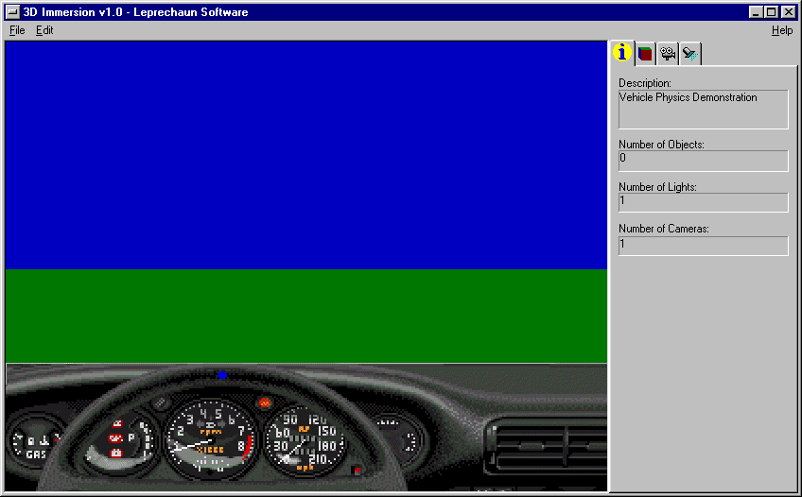 | One world being developed will simulate real car physics in taking speedy turns, flying off ramps, and going up steep hills.

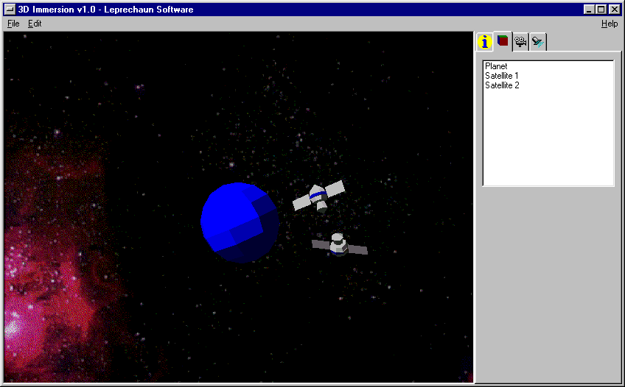 | The sample world to the left demonstrates Kepler’s Law for planetary bodies in which the mass of the satellites and the planet are specified as well as the initial linear and rotational velocities and accelerations and using the formula are dynamically updated.
Some other worlds already developed or which are in development are fear of heights (prototype), claustrophobia (started), simple island with lighthouse and lapping ocean (completed), interactive three dimensional desktop interface, as well as many others such as an example of dynamic landscape.
The program is very powerful having many potential applications that can be exploited with a right amount of ingenuity. Unfortunately, however, simulating the third dimension on a two dimensional screen is less then immersive and would greatly benefit from technologies such as data gloves, head mounted displays (HMD), and other immersive technologies that enable the user to fully interact in a pseudo-reality with convincing auditory, visual, and sensory feedback. Such technologies are unfortunately out of my reach, but may becoming feasible in future with increasing demand.
Conclusion(s)

Jeremiah Cornelious McCarthy
Leprechaun Software
Lepresoft@nf.sympatico.ca

